ESC-10043 - Greening Business: Employability and Sustainability
ESC-00004 - Greening Business: An Introduction

Group Working Handbook

This booklet contains a number of supplementary materials designed to support the group working processes involved in this module, including exercises which you will work through with your group. Sections are listed below:
1) Introduction to group working – page 1
2) Skills developed through group working – page 2
3) Team decision making – page 2
4) Setting ground rules for teamwork (Exercise A) – page 3
5) Team roles (Exercise B) - page 4
6) Dealing with group conflict (Exercise C) - page 6
7) What are Graduate Attributes and how does working in a group contribute towards them? (Exercise D) – page 6/7
1) Introduction to group working
During the class sessions of this module you will be working in groups of 4 or 5 exploring different scenarios and tasks which relate to sustainability and greening businesses. Together with your group you will be devising recommendations and action plans for these scenarios. You will also be involved in class discussions, debates and presentations. You will be encouraged to exchange ideas, feelings and experiences with your group.
Module content will not be delivered in a traditional lecture style. It will be delivered online via podcasts and PowerPoint slides which you will be expected to access on a weekly basis. These will form the basis of discussions in class and will provide background information to help you in your assessments.
The module leader and facilitator will monitor group learning and will be on hand to provide guidance and support. When you are given a sustainability task to work through in class you should roughly follow this process as a group:

2) Skills developed through group working

“A team is a group of people with complementary skills who are committed to a common purpose and hold themselves mutually accountable for its achievement” (Katzenbach and Smith, 1993)
Much of the work on this module involves working in a team and performing together as a team. Being ‘mutually accountable’ means that all group members are jointly responsible for the achievement of the team and must all pull their weight. Some of the skills you are likely to develop and gain confidence in through group working include:
- Problem solving skills
- Listening and negotiating skills
- Communicating in a group
- Communicating to a large group of people, i.e. presentations and answering questions
- Dealing with conflicts
- Sharing responsibilities within a team
- Managing a project and prioritising tasks
- Leadership skills
- Working in an interdisciplinary team
- Working in an international team
- Creative and entrepreneurial thinking

3) Team decision making
Team decision-making is a complex process which is underpinned by group discussions, questioning and pulling together evidence to support decisions. During your group work projects you may wish to consult the following criteria when making decisions as a group or choosing between different options and ideas.
- Weigh up the advantages and disadvantages of each option
- Think about previous similar decisions and the results which occurred
- Consider what resources will be needed and what is feasible
- Consider what is being required of your group – are you answering the question that has been asked and fulfilling the task that has been set?
- Consider what criteria you will be judged/marked upon
- Can you all agree?
- Have you all listened to all opinions and weighed these up?

4) Setting ground rules for teamwork
Exercise A – Ground rules
Consider your experience of working in a team and what ground rules you think should be put in place in order to promote appropriate behaviour and attitudes towards group roles and responsibilities. Each group should agree upon at least 5 ground rules for their team:

1.

2.

3.

4.

5.

6.

7.

Ground rules for teamwork generally fall into three main categories:
- Team culture - this category deals with promoting an environment within the group which is beneficial to team working, e.g. everybody is given the chance to speak, or everyone’s opinions are taken on board.
- Team member responsibilities - this category deals with an individual's behaviour within the team, e.g. team members must strive to always be on time and turn up to all meetings, or team members should let the group know in advance if they will be unable to make a meeting.
- Team organisation - this category deals with generic management activities which should underpin the work of any successful team, e.g. the group must keep regular minutes of meetings and type up all agreed actions and responsibilities, or everybody must check their emails/Facebook at least daily

5) Team roles
There are many different roles which people perform within a team. The ‘Belbin’ team roles exercise is used to identify people’s behavioural strengths and weaknesses whilst working in groups and in the workplace. There are 9 team roles, each has good and bad points and a balance of roles is important in any team. In smaller groups one person may carry out several of the roles.

Exercise B - Team roles
Look through the descriptions of Belbin team roles on the next page, and briefly answer the following questions with your group:
- Which is most and least like you (you may identify with more than one team role)?

- In your group are there any roles that are missing or roles that are over-abundant?

- How do you think the team roles present in your group will be likely to affect the way you work as a team?

Belbin Team Roles

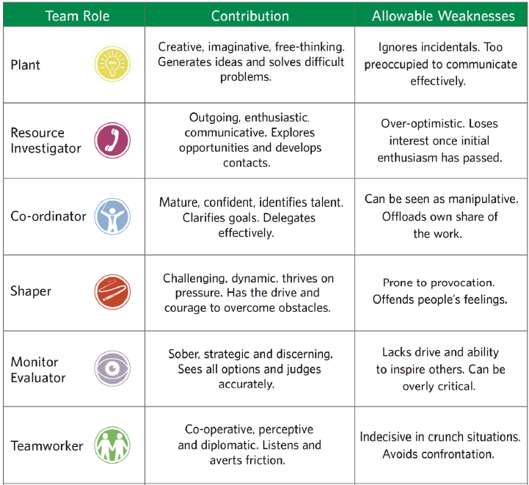
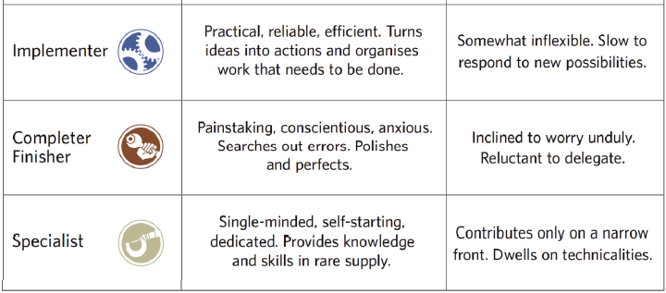
6) Dealing with group conflict
If you have a productive team with an effective team culture, team members should be able to:
“Trust one another. Engage in unfiltered conflict around ideas. Commit to decisions and plans of action. Hold one another accountable for delivering against those plans. Focus on the achievement of collective results” (Lencioni, 2002)
Lencioni (2002) describes five dysfunctions of team working:
- Absence of trust between group members
- Fear of conflict and individuals thus being wary to engage in open discussion
- Lack of commitment and members who are reluctant to commit fully to the task at hand
- Avoiding accountability and responsibility for group work
- Disregard for team results and individuals putting their own needs first

When we think about conflict the most visible types of conflict, such as arguments, spring to mind first. Conflict in teams however comes in many forms, some examples are given below:
- A dominant team-member causing disharmony by imposing their will on others.
- A team culture which denies individuals the opportunity to voice differing opinions.
- Fragmentation of the team into sub-groups, each with their own agenda.
- A team-member who does not pull their weight, or is inflexible.

Exercise C – Issues which may lead to conflicts
In your group, each member of the team should be given about two minutes to talk about any issues they feel could lead to conflict within the team. This could be something that they have experienced, have observed, or are concerned may occur. All team members should agree on how the problem could be avoided or overcome.

6) What are Graduate Attributes and how does working in a group contribute towards them?
Graduate attributes are the qualities and skills that students develop during their time at university. These attributes are more than just what you learn within your specific subject area. They are qualities that increase individual confidence; prepare graduates for the world of work; build problem-solving skills; and help graduates to appreciate the importance of contributing positively towards society, communities and the environment. The Keele Graduate Attributes are shown on the next page.
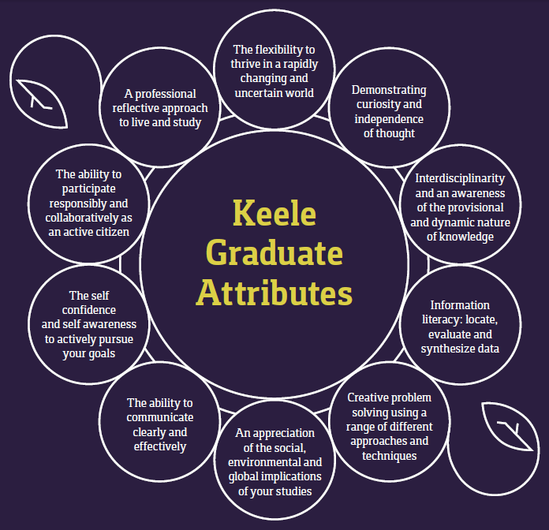
Exercise D - Graduate Attributes
- Make a list of 3 graduate attributes and qualities that you hope to gain/improve upon during this module and explain why.
1.

2.

3.

- How will these attributes help you in your future life?

It is very important that you are able to articulate your skills and tell people about them. This is vital for your own self-confidence, for when you are applying for jobs and when you’re meeting new people. Don’t be afraid to sell yourself and your attributes!

